IV BAG MONITORING AND ALERT SYSTEM

**FIELD OF INVENTION:**

The present invention is based on IV BAG monitoring and alert system based on IOT.

**BACKGROUND OF THE PRESENT INVENTION:**

In the process of medication, it is a common practice to treat patients with saline for dehydration and other medical ailments to improve the health condition of the patients. When fed with saline continuous observation of nurses is mandatory in monitoring the saline level. In many cases, patients are harmed due to the staff's inattentiveness, as their absence does not notice the container's completion of the saline level. This raises the problem of blood backflow immediately after saline completion in a container. Hence, an IoT-based IV BAG monitoring system has been developed to protect the patient from getting harmed. The proposed model incorporates a sensor that continuously detects the weight of the IV BAG and alerts the hospital staff with the buzzer, helping to monitor the safety of the patients.

**LITERATURE GAPS:**

The gaps observed in the literature are listed below:

* Effectiveness of IV bag monitoring and alert systems in preventing errors and adverse events.
* The optimal design and implementation of IV bag monitoring and alert systems. There is a need for more research to determine the most effective types of alerts, the optimal frequency of alerts, and the best ways to integrate these systems into clinical workflows.
* Lack of research on the cost-effectiveness of IV bag monitoring and alert systems. While these systems may effectively reduce errors and improve patient outcomes, it is still being determined whether they are cost-effective and whether the benefits outweigh the costs.

**OBJECTIVE OF THE INVENTION:**

An IV bag monitoring and alert system in IoT (Internet of Things) aims to provide healthcare professionals with real-time information on IV (intravenous) fluid bag status to ensure that patients receive the correct medication and dosage at the appropriate times. Monitoring the volume of IV fluid remaining in the bag and alerting healthcare professionals when the bag needs to be replaced.

**DETAILED DESCRIPTION OF THE ELEMENTS:**

The IV BAG monitoring and alert system consists of the following elements:

**1. Weight Sensor:**

The weight sensor is a critical IV bag monitoring and alert system component. It is used to monitor the weight of the IV bag and provide real-time information on the volume of fluid remaining in the bag. The weight sensor is typically under the IV bag and can be a load cell or a strain gauge. When the IV bag is placed on the weight sensor, the bag's weight is measured, and an alert is sent to the health professionals.

**2. Alert System:**

The alert system is a critical element of an IV bag monitoring and alert system. It is designed to notify healthcare professionals of any IV bags issues, such as low fluid levels, high or low flow rates, or abnormal temperatures. The alert system can be configured to send alerts via the buzzer.

**CIRCUIT DIAGRAM**

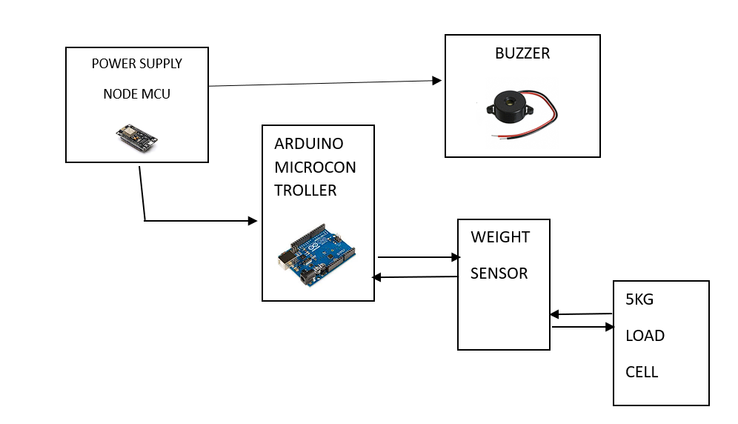

**ABSTRACT:**

In hospitals, in the process of medication to patients, when the patients are fed with saline, they must be constantly monitored. More often, in the busy continuous schedule of the staff attending the large set of patients, the nurse may forget to monitor and change the saline bottle as soon as its completion. Thus the blood rushes back to the saline bottle through the intravenous tube because of the imbalance between the blood pressure and pressure within the empty saline bottle. This may cause the backflow of blood from their vein through the cannula, resulting in reduced patient hemoglobin levels and a shortage of red blood cells (RBCs). Patients most frequently face this problem in hospitals. This may even lead to a patient's death. So to overcome this problem, an IV bag monitoring and alert system must be developed to reduce patients' dependency on nurses. In this system, whenever the saline in the bottle completes, it automatically gives a buzzer alerting the staff about the completion of saline in the bottle. By this, we can avoid the patient's problems, and even the hospital staff feel at ease. This system improves efficiency in the work giving greater results in hospital maintenance.

**WORKING PROCEDURE:**

The IV bag monitoring and alert system is designed to continuously monitor the IV fluid level in an IV bag and alert the healthcare provider when the level falls below a certain threshold. The following is a general working procedure for an IV bag monitoring and alert system:

1. Sensor Placement: A sensor is placed on the IV bag, which is used to detect the fluid level in the bag.

2. Sensor Readings: The sensor sends the readings to a microcontroller responsible for processing the data.

3. Data Processing: The microcontroller processes and compares the data with the predefined threshold level. If the fluid level in the bag goes below the threshold level, the system generates an alert.

4. Alert Generation: The alert is generated using a buzzer connected to the microcontroller. The buzzer starts beeping to notify the medical staff when the fluid level falls below the threshold.

5. Notification: The buzzer serves as a notification mechanism to alert the medical staff that the fluid level in the IV bag has fallen below a predefined threshold.

6. Maintenance: The system requires periodic maintenance to ensure proper functioning of the sensor and microcontroller. The IV bag should also be replaced when it is empty to prevent any delay in treatment.

**OUTPUT FROM THE PROCESS:**

The output of an IV bag monitoring system can vary depending on the specific features and capabilities of the system. Still, typically it provides information about the status of the IV bag, including:

* Weight measurement: The weight sensor will measure the weight of the IV bag and provide real-time data on the amount of fluid remaining in the bag.
* Weight threshold: The system will be programmed with a weight threshold, the minimum weight the IV bag should have before an alert is triggered.
* Alert trigger: If the weight of the IV bag falls below the set threshold, the system will trigger the buzzer to sound an alarm or alert.
* Alert acknowledgment: A healthcare provider must acknowledge the alert and take appropriate action, such as refilling or replacing the IV bag, before silencing the alarm.

.